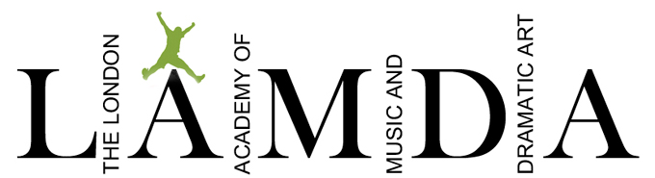
At Stafford Grammar & Prep School

APPLICATION FORM FOR LAMDA TUITION

I/We would like ................................................................................................ (Name of student in block capitals please) to have shared/individual* LAMDA lessons (*Please circle or delete as applicable).

(Duologue lessons are £10.50 per week and individual lessons are £17 per week)

School Year Group 2022/2023 ...................................... Date of Birth ............................................

Signature of parent/guardian* ............................................................. (*Please delete as applicable)

Home Contact Details:-

Parent/s Title/s ……………………………………………………

Parent/s Name/s ……………………………………………………

Postal Address ……………………………………………………

……………………………………………………

……………………………………………………

Postcode ……………………………………………………

Home Telephone ……………………………………………………

Mobile Number ................................................................................

Email address ................................................................................ (Please print clearly)

Please note letters, timetables and invoices will be sent via email.

One term’s notice is required on the acceptance of this form should your child no longer wish to have LAMDA lessons.

Return: For the attention of Miss V. Gotham to Stafford Grammar School or email it to v.gotham@staffordgrammar.co.uk

